**NOTICE OF PUBLIC HEARING**

**BEFORE THE CITY OF BANDON HEARINGS OFFICER**

Notice is hereby given that a Public Hearing on appeal has been set before the City of Bandon Hearings Officer, regarding application #22-030, a request for Geologic Assessment Review to construct a new single-family dwelling on property zoned CD-1 in the City of Bandon. This is a continuation of a prior hearing that had to be rescheduled.

|  |  |
| --- | --- |
| Applicant: | Dave Reed |
| Property Owners: | T & C Coan Living Trust |
| Application Number: | 22-030 |
| Lead Staff: | Dana Nichols, Planning Manager |
| Hearings Officer: | Gary Darnielle, LCOG |
| Property Location: | 0 Beach Loop Drive SW (29S-15W-01BB / TL 2000) |
| Request: | Appeal of a Type II decision approving a request for a Geologic Assessment Review to construct a new single-family dwelling. |
| Date of review: | Wednesday, November 2, 2022 at 1:30 PM |
| Applicable Criteria (BMC): | 17.78 Hazards Overlay Zone |

The hearing has been set for **Wednesday, November 2nd** at **1:30 p.m.** and will be conducted exclusively through a Zoom Meeting.

The meeting can be accessed by using the following credentials:

Meeting Link: <https://us02web.zoom.us/j/2157059460>

Meeting ID: 215 705 9460

The meeting link, as well as application materials and supporting documents, can be viewed on the Planning Department’s webpage, through [www.cityofbandon.org](http://www.cityofbandon.org).

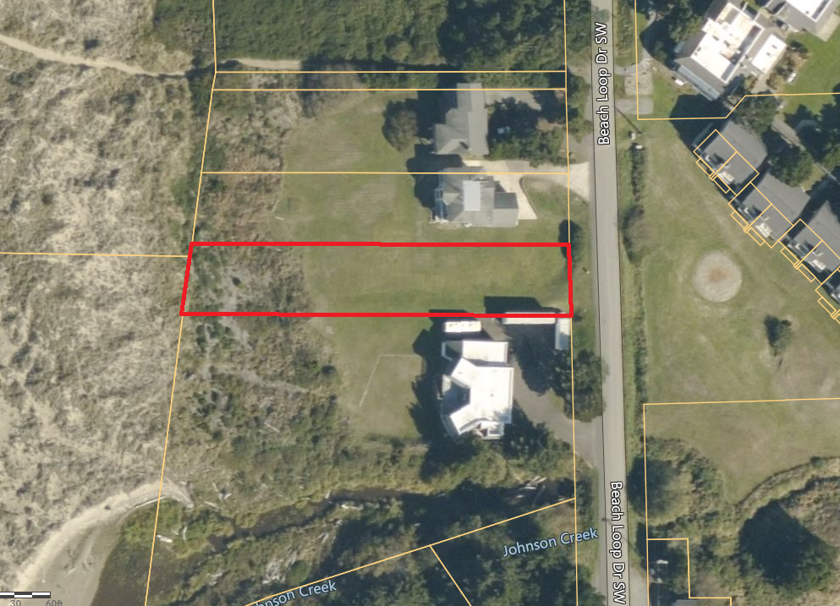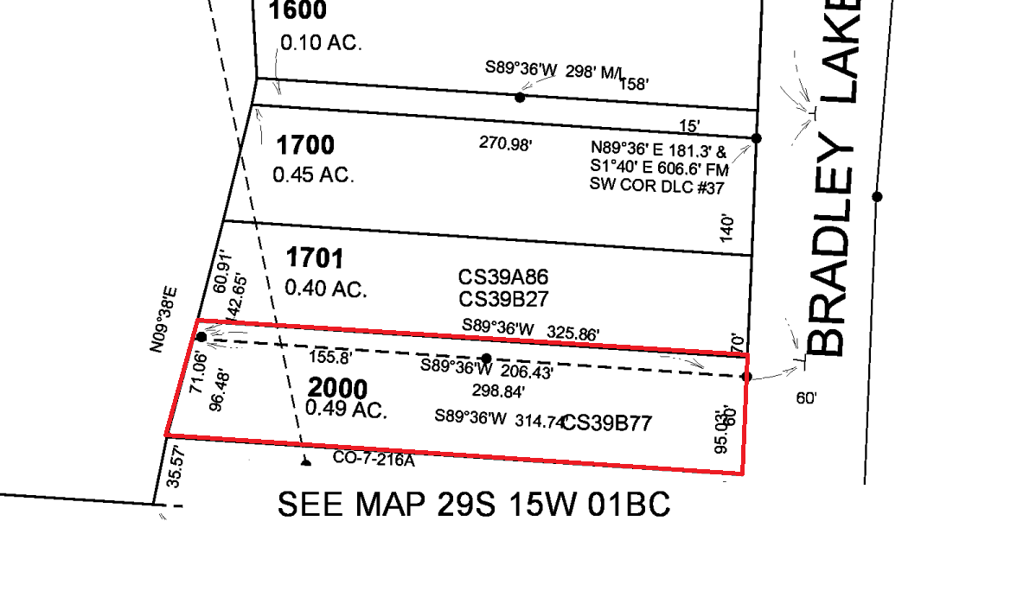

|  |
| --- |
| The ordinance criteria applicable to this application is available to review in the Bandon Municipal Code, which can be found online in the Bandon Municipal Code at [www.cityofbandon.org](http://www.cityofbandon.org). Oregon law states that failure to raise an objection concerning this application, either in person or by letter, or failure to provide sufficient specificity to afford the decision maker an opportunity to respond to the issue, precludes your right of appeal to the Land Use Board of Appeals (LUBA) on that issue. Failure to specify which ordinance criterion the objection is based on also precludes your right of appeal to LUBA on that criterion. A copy of the application, all documents and evidence relied upon by the applicant and applicable criteria will be available for review on the City’s website [www.cityofbandon.org](http://www.cityofbandon.org), and will be provided at cost, if requested. A copy of the Staff Report will be available for inspection ten days prior to the hearing and will be provided at cost, if requested. All materials are available online and at the Bandon Planning Department, 555 Hwy 101, and Bandon, Oregon 97411. During the Public Hearing, the Chair shall allow testimony from the applicant and those in attendance concerning this request. The Chair shall have the right to limit the length of testimony and require that comments be restricted to the applicable criteria.  If you have questions concerning this request, please contact the Planning Department  at [Planning@cityofbandon.org](mailto:Planning@cityofbandon.org) or (541) 347-7922. |